# Benthic monitoring summary: American Samoa 2018

## About this summary

The purpose of this document is to provide a brief summary of the most recent survey efforts performed in American Samoa in 2018 by the Ecosystem Sciences Division (ESD) of the NOAA Pacific Islands Fisheries Science Center as part of the Pacific Reef Assessment and Monitoring Program (Pacific RAMP). A more detailed assessment of the coral populations and reef community structure from American Samoa will be summarized in future publications.

## Sampling effort

* Ecological monitoring in American Samoa was performed from June 19 - July 18, 2018.
* Benthic surveys were conducted at 95 sites around: Swains, Tutuila, Ofu & Olosega, Tau, Rose.
* Coral demography, partial mortality, and condition were surveyed using belt transects; benthic community structure will be assessed from photoquadrat digital images.

###### Table 1. Forereef area (hectare) and number of sites surveyed (nS, nM and nD = the number of sites surveyed within shallow (0 - 6 m), mid (>6 - 12 m) and deep (>18 - 30 m) strata, respectively, in American Samoa.

|  |  |  |  |  |  |  |
| --- | --- | --- | --- | --- | --- | --- |
| Island | Shallow | nshallow | Mid | nmid | Deep | ndeep |
| Ofu & Olosega | 120.67 | 4 | 369.01 | 7 | 303.69 | 6 |
| Rose | 18.49 | 5 | 85.30 | 6 | 16.50 | 3 |
| Swains | 210.78 | 4 | 57.42 | 3 | 12.30 | 2 |
| Tau | 133.72 | 3 | 566.64 | 8 | 203.51 | 4 |
| Tutuila | 1183.55 | 9 | 1801.98 | 17 | 1492.48 | 14 |

## Overview of data collected

###### Figure 1. Mean density of adult coral colonies (Scleractinia, >= 5 cm) at survey sites.

###### Figure 2. Mean density of juvenile coral colonies (Scleractinia, < 5 cm) at survey sites.

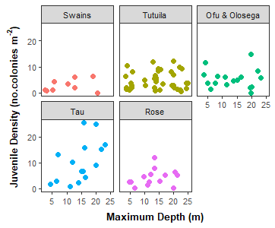

###### Figure 3. Density of juvenile coral colonies grouped by island across maximum site depth (ft).

## Scale for 'x' is already present. Adding another scale for 'x', which  
## will replace the existing scale.

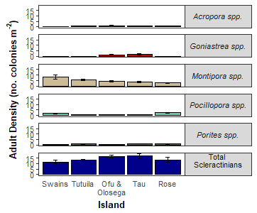

###### Figure 4. Mean island-wide density of adult colonies (± SE) for total scleractinians and the four most abundant genera: Acropora, Goniastrea, Montipora, Pocillopora,and Porites.

## Scale for 'x' is already present. Adding another scale for 'x', which  
## will replace the existing scale.

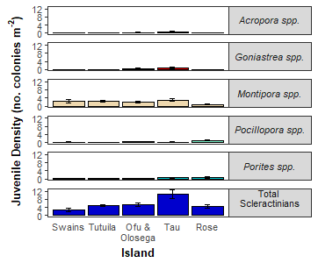 ###### Figure 5. Mean island-wide density of juvenile colonies (± SE) for total scleractinians and the four most abundant genera: Acropora, Goniastrea, Montipora, Pocillopora,and Porites.

*Coral condition and threatened species*- The percent of adult coral colonies exhibiting signs of bleaching, disease, or crown-of-thorns sea star (COTS) predation lesions, as well as the mean percent of each colony with partial mortality, are shown in Table 2. Bleaching included any loss of pigmentation. Acute Disease was defined diseases resulting in tissue mortality. Chronic Disease refers to diseases that did not result in tissue loss. COTS was defined as recent coral mortality attributable to COTS predation. The Endangered Species Act threatened species Isopora crateriformis was observed at Ofu & Olosega, Tutuila and Ta'u Islands. Acropora retusa was observed at Rose Atoll and Acropora globiceps was observed at Tutuila Island.

###### Table 2. Percent of adult coral colonies that exhibited bleaching (BLE), acute and chronic disease, crown-of-thorns sea star (COTS) predation lesions and partial mortality (including old and recent).

|  |  |  |  |  |  |
| --- | --- | --- | --- | --- | --- |
| ISLAND | meanBLE | meanAcuteDZ | meanChrDZ | meanCOTS | meanAllDead |
| Ofu & Olosega | 0.11 | 0.66 | 0.07 | 0.00 | 11.65 |
| Rose | 0.62 | 0.95 | 0.00 | 0.00 | 8.77 |
| Swains | 5.16 | 0.16 | 0.21 | 0.00 | 15.70 |
| Tau | 0.00 | 0.27 | 0.27 | 0.00 | 13.13 |
| Tutuila | 0.22 | 0.90 | 0.51 | 0.03 | 11.12 |

## Preliminary observations

## Survey design & methods

A single-stage stratified random sampling design was employed to survey American Samoa. The stratification scheme incorporated all forereef, hard-bottom habitats, and sampled across three depth strata: shallow (0-6 m), mid (>6-18 m) and deep (>18-30 m). Allocation of sampling effort was proportional to total strata area. Sites (geographic coordinates) were randomly selected within each stratum.

Coral demography surveys at each site were conducted along one belt transect. Adult coral colonies (??? 5 cm) were surveyed within 10 m2 and juvenile coral colonies (< 5 cm) were surveyed within 3 m2 on each transect. Colonies were identified to the lowest taxonomic level possible, measured (maximum diameter to the nearest cm), and morphology was noted. In addition, partial mortality and condition of each colony was assessed. Partial colony mortality was quantified as the percent of old and recent dead tissue, and attributed to cause of mortality when known. Conditions affecting each colony (i.e., disease and bleaching) were noted, along with the extent (percent of colony affected) and severity (ranging from moderate to acute). See <https://repository.library.noaa.gov/view/noaa/18267> for details on survey methodology

The present summary focuses only on colony density and initial estimates of bleaching, disease, and COTS predation occurrence. The island-scale estimates presented here are generated from site-level means and are not weighted by reef area within depth strata, statistical analyses are forthcoming.

## About the monitoring program

Pacific RAMP forms a key part of the National Coral Reef Monitoring Program of NOAA's Coral Reef Conservation Program (CRCP), providing integrated, consistent, and comparable data across US Pacific islands and atolls. CRCP monitoring efforts have these aims:

* Document the status of reef species of ecological and economic importance
* Track and assess the status and trends of US coral reef ecosystems in response to environmental stressors and human activities
* Evaluate the effectiveness of specific management strategies and identify actions for future and adaptive responses

In addition to the coral population and benthic community surveys outlined here, Pacific RAMP efforts include interdisciplinary monitoring of oceanographic conditions, fish population and assemblages, invertebrate diversity and abundance, coral reef habitat assessments and mapping, and studies of the effects of climate change and ocean acidification. Data are available upon request.

## For more information

Coral Reef Conservation Program:  
<http://coralreef.noaa.gov>  
NMFS Pacific Islands Fisheries Science Center:  
<http://www.pifsc.noaa.gov>  
Related publications:  
<http://www.pifsc.noaa.gov/pubs/credpub.php>  
Additional information:  
<http://www.pifsc.noaa.gov/cred/benthic_monitoring.php>  
Benthic team lead:  
[bernardo.vargasangel@noaa.gov](mailto:bernardo.vargasangel@noaa.gov)  
Benthic survey data requests:  
[courtney.s.couch@noaa.gov](mailto:courtney.s.couch@noaa.gov)